# SLF4J logging framework

# SL4J Logging exercises

**Exercise 1: Logging Error Messages and Warning Levels**

Task: Write a Java application that demonstrates logging error messages and warning levels

using SLF4J.

**Step-by-Step Solution:**

1. Add SLF4J and Logback dependencies to your `pom.xml` file:

***Pom.xml***

<dependency>

<groupId>org.slf4j</groupId>

<artifactId>slf4j-api</artifactId>

<version>1.7.30</version>

</dependency>

<dependency>

<groupId>ch.qos.logback</groupId>

<artifactId>logback-classic</artifactId>

<version>1.2.3</version>

</dependency>

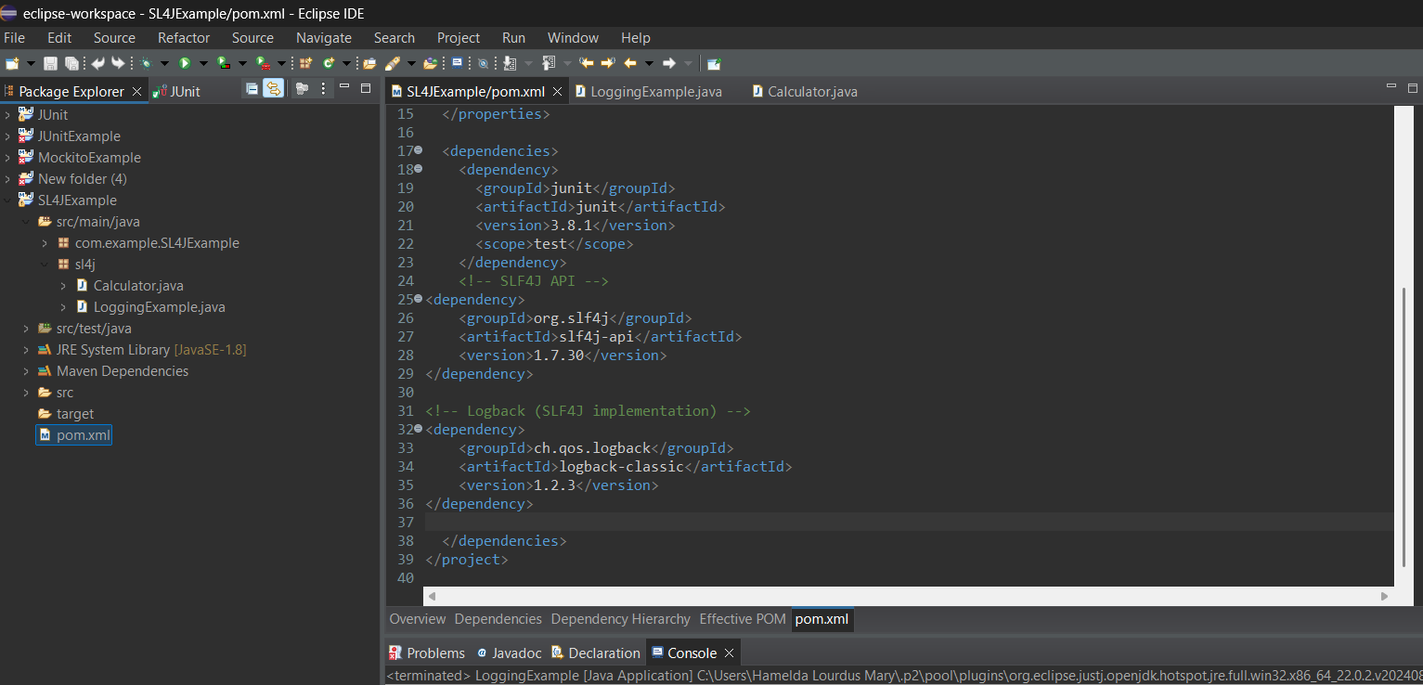

1. Create a Java class that uses SLF4J for logging:

***Create a class- src/main/java/sl4j/Calculator.java***

package sl4j;

import org.slf4j.Logger;

import org.slf4j.LoggerFactory;

public class Calculator {

private static final Logger logger = LoggerFactory.getLogger(Calculator.class);

public int add(int a, int b) {

logger.info("Adding {} and {}", a, b);

return a + b;

}

public int subtract(int a, int b) {

logger.debug("Subtracting {} from {}", b, a);

return a - b;

}

public int multiply(int a, int b) {

logger.debug("Multiplying {} and {}", a, b);

return a * b;

}

public int divide(int a, int b) {

if (b == 0) {

logger.error("Division by zero attempted: {}/{}", a, b);

throw new IllegalArgumentException("Cannot divide by zero");

}

logger.warn("Be cautious: division can lead to precision loss");

return a / b;

}

}

***Create a class- src/main/java/sl4j/LoggingExample.java***

package sl4j;

import org.slf4j.Logger;

import org.slf4j.LoggerFactory;

public class LoggingExample {

private static final Logger logger = LoggerFactory.getLogger(LoggingExample.class);

public static void main(String[] args) {

logger.info("Application started");

Calculator calculator = new Calculator();

int a = 10;

int b = 5;

logger.info("Performing calculations with a = {}, b = {}", a, b);

int sum = calculator.add(a, b);

logger.info("Sum: {}", sum);

int diff = calculator.subtract(a, b);

logger.info("Difference: {}", diff);

int product = calculator.multiply(a, b);

logger.info("Product: {}", product);

try {

int quotient = calculator.divide(a, b);

logger.info("Quotient: {}", quotient);

} catch (Exception e) {

logger.error("Error during division: {}", e.getMessage());

}

logger.info("Application finished");

}

}

**Output:**

23:25:01.240 [main] INFO sl4j.LoggingExample - Application started

23:25:01.249 [main] INFO sl4j.LoggingExample - Performing calculations with a = 10, b = 5

23:25:01.251 [main] INFO sl4j.Calculator - Adding 10 and 5

23:25:01.251 [main] INFO sl4j.LoggingExample - Sum: 15

23:25:01.251 [main] DEBUG sl4j.Calculator - Subtracting 5 from 10

23:25:01.251 [main] INFO sl4j.LoggingExample - Difference: 5

23:25:01.252 [main] DEBUG sl4j.Calculator - Multiplying 10 and 5

23:25:01.252 [main] INFO sl4j.LoggingExample - Product: 50

23:25:01.252 [main] WARN sl4j.Calculator - Be cautious: division can lead to precision loss

23:25:01.252 [main] INFO sl4j.LoggingExample - Quotient: 2

23:25:01.252 [main] INFO sl4j.LoggingExample - Application finished

